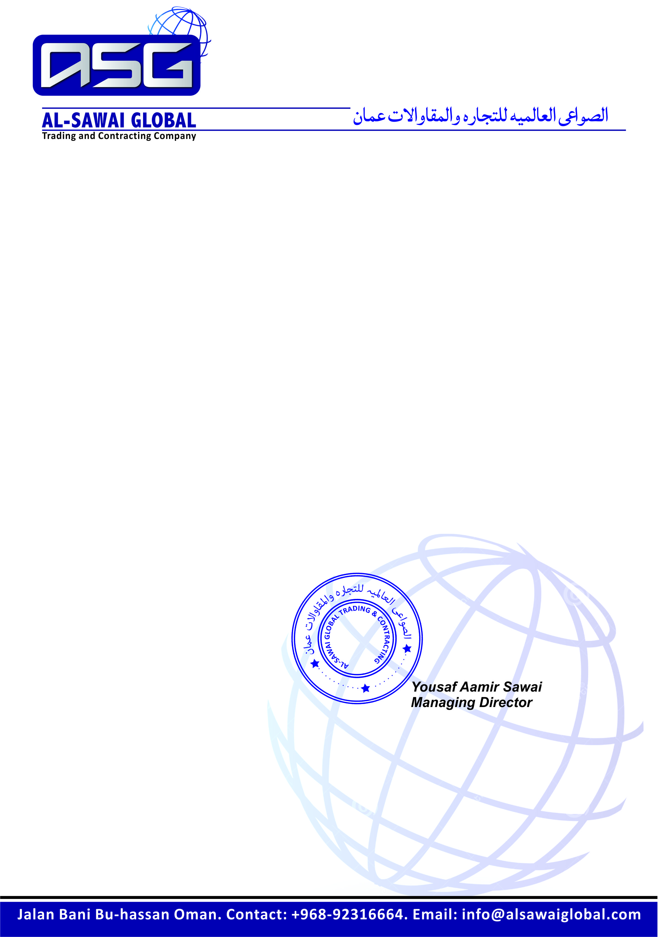

*Ref No: ASG-14-8851 Date: <To2>*

***TO WHOM IT MAY CONCERN***

It is certified that Mr. <Name> <fname> Passport Number <Passport> worked with us as a <Designation> in Al-Sawai Global Trading and Contracting Company Oman from <From2> to <To2>.

During his services period we found him hardworking intelligent and having vast experience in this field.

He left the services on his own accord.

